Open Medical Student Education Research Grant (MSERG)
2020 Application Form
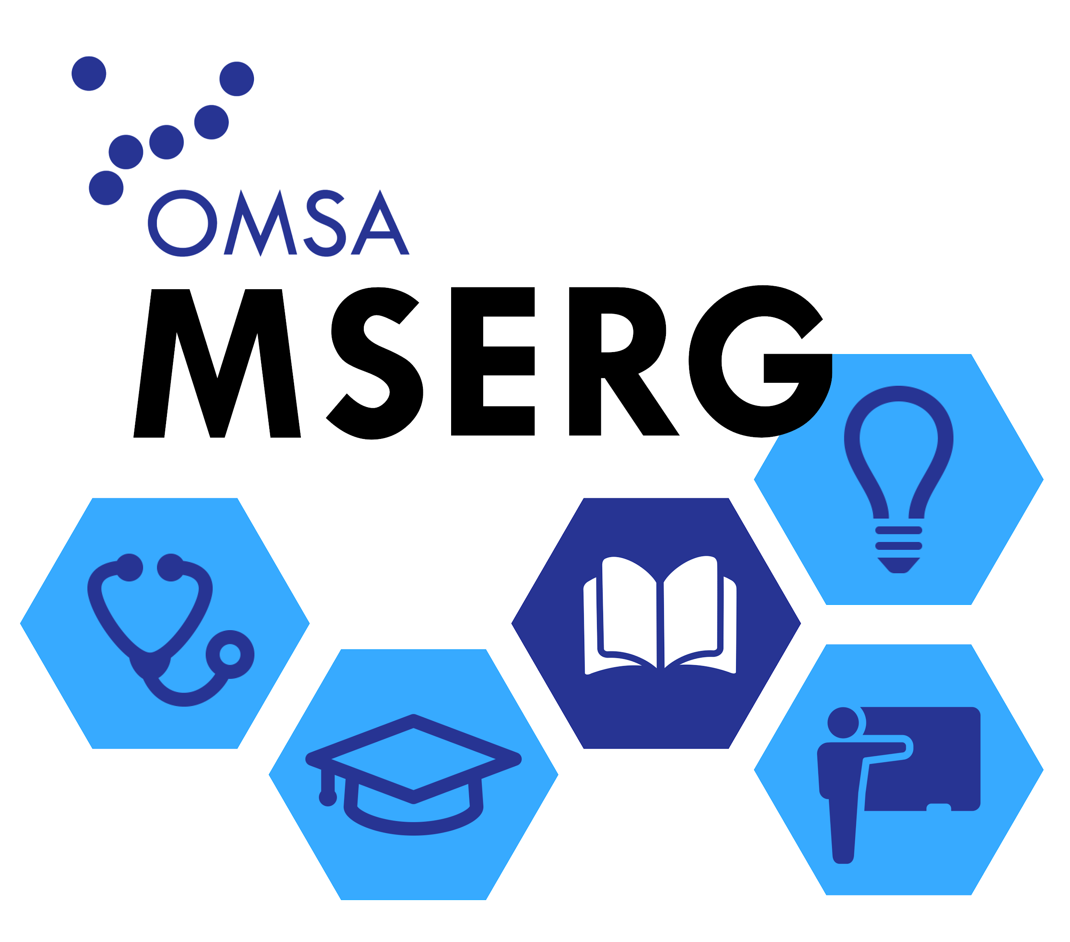
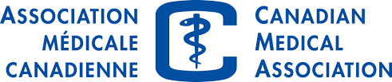
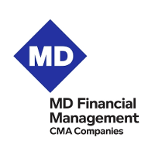

Please submit your completed, de-identified application form to mserg@omsa.ca no later than 11:30 pm on March 30th, 2020 using the subject line "OMSA Open MSERG application - [Applicant name]". Remember to attach the applicant’s CV as a separate documents -- this item should not be de-identified. Please refer to the Call for Applications for complete details regarding the application requirements.
TITLE OF PROPOSAL:
APPLICANT INFORMATION:
If submitting with a co-applicant, please include name, medical school, year of study, and email for both applicants.
Please only list a phone number and mailing address for one applicant; the cheque will be mailed to this address.
Name(s):
Medical school:
Year(s) of study:
E-mail(s):
Phone number:
Mailing address:

PRINCIPAL INVESTIGATOR:
Name:
Institutional affiliation(s):
E-mail:
CO-INVESTIGATORS:
Name(s) and institutional affiliation(s):
PROPOSAL:
Please complete the following sections of this form and e-mail the completed document to mserg@omsa.ca. The proposal should be written in 11 pt Calibri font and should be submitted as a word document. No graphics or figures should be included (tables for the timeline are allowed). Failure to follow the formatting guidelines will result in applicant disqualification.
- Please avoid the use of identifiers in the proposal (e.g. applicant name, name of medical school, or names of co-investigators, including the PI).
- Please include total word count within each section next to the headings.
Title:
Abstract: Maximum 200 words.
Suggested headings include: Introduction, Research Question, Rationale, Methods, Impact, etc.
Depending on the proposal, some of the following headings might not be applicable, therefore, unstructured abstracts are also accepted.

Issue/Background and Research objective: Maximum 150 words.
Describe what is known in the existing literature about the topic you wish to study and highlight a gap in knowledge that requires further research to address.
Please provide a clear research objective or question for your study.

Research design and methods: Maximum 300 words.
Ensure that the research design and methods are appropriate for the stated research objective(s).
Suggested headings include: Overall design, Subjects/participants, Sample, Data collection, Data analysis. Depending on the proposal, some of the following headings might not be applicable.

Implications: Maximum 250 words.
How might the findings of your study contribute to the advancement of medical education?
Use the headings: Impact of the Proposed Study, Future Plans.

Timeline: Maximum 150 words.
What is the proposed timeline for your study?
When do you expect to obtain your results and when do you expect to publish or present your results?

Personnel: Maximum 200 words.
What is the expertise of the investigators involved in this proposal and how might this contribute to the success of your study?
Please clearly state the role of the applicant(s), principal investigator, and each co-investigator.

References: No maximum word count.
Include references here using the referencing format of your choice.

